# CS 255 System Design Document Template

This template lays out all the different sections that you need to complete for Project Two. Each section has guidance to prompt your thinking. You will need to continually reference the interview transcript as you work to make sure that you are addressing your client’s needs. There is no required length for the final document. Instead the goal is to complete each section based on what your client’s needs are. Remove this note when you are finished, and replace all bracketed text with the relevant information.

## UML Diagrams

### UML Use Case Diagram

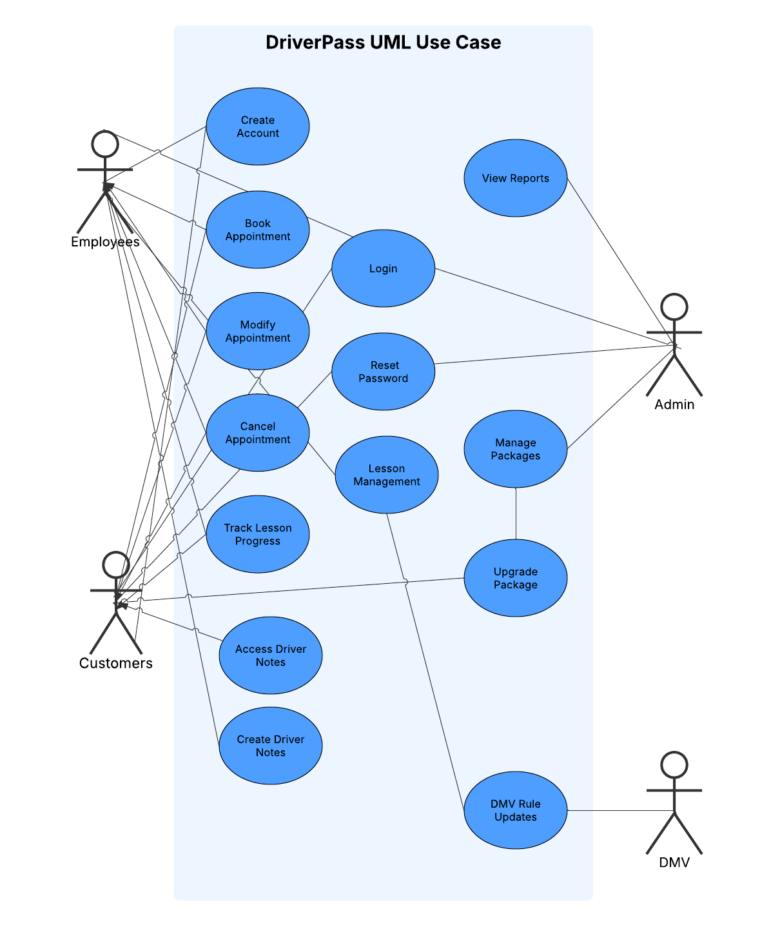

### UML Activity Diagrams

Reset Password Book Appointment

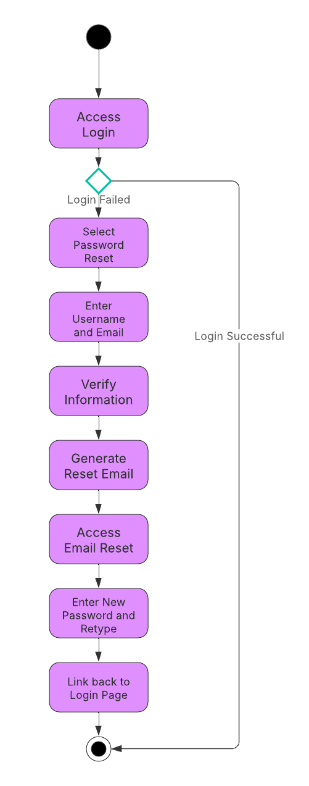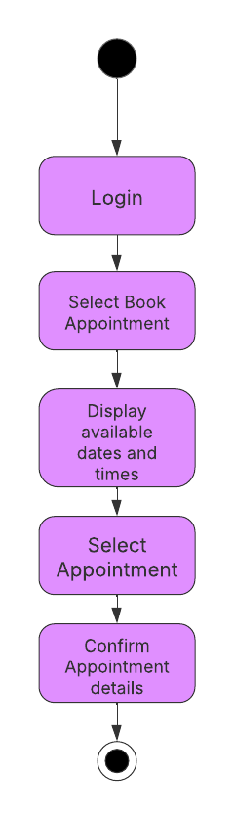

### UML Sequence Diagram

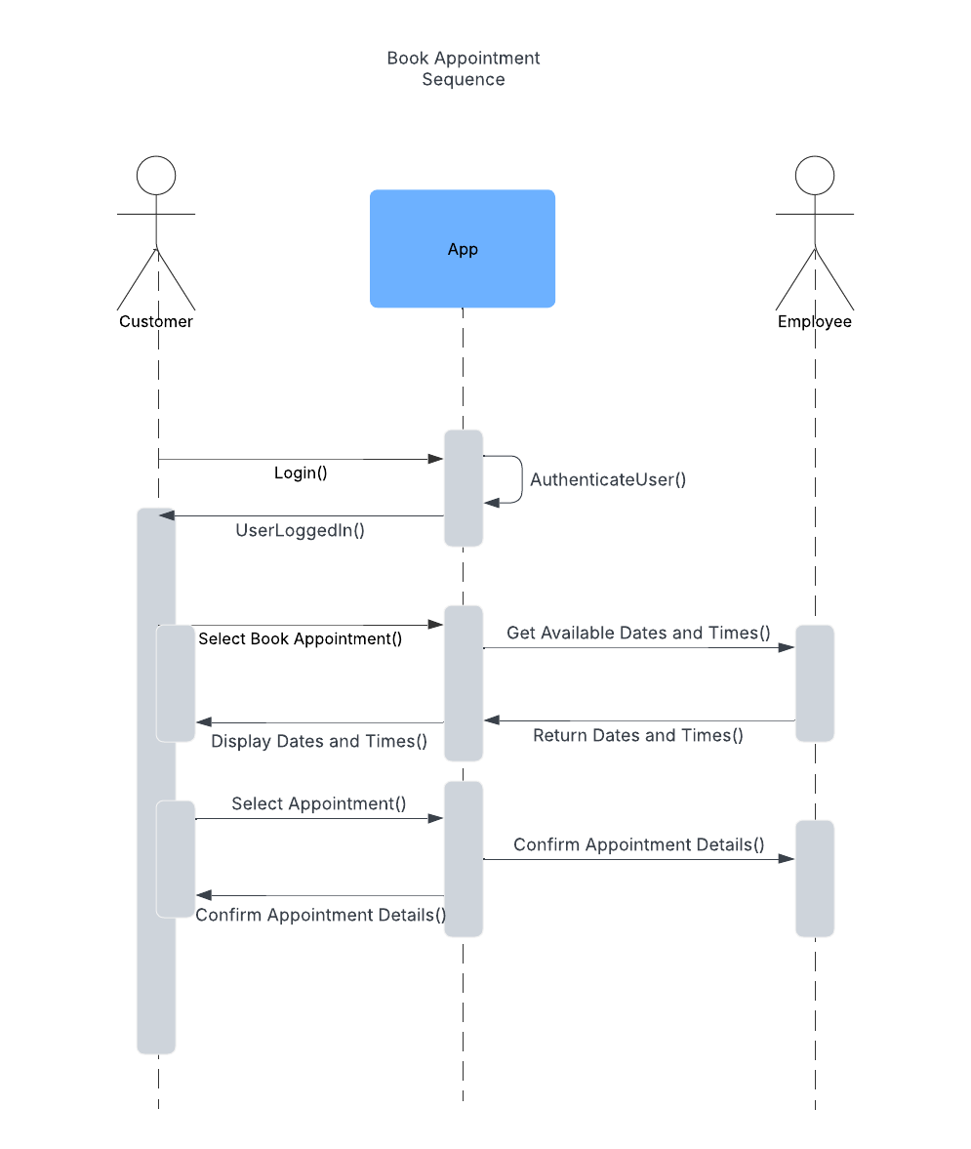

### UML Class Diagram

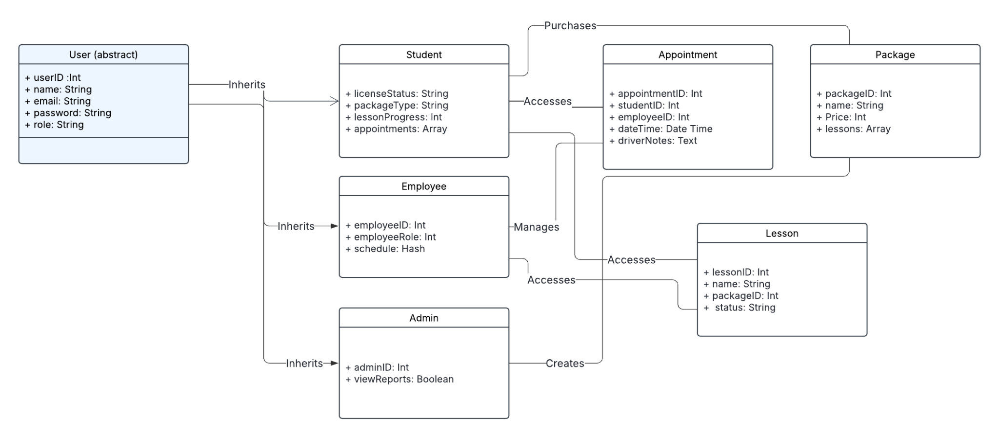

## Technical Requirements

The DriverPass system requires functional requirements. A cloud-based infrastructure with AWS hosting. AWS will allow for scalability and long trusted security. It will use Ruby on Rails for the backend, PostgreSQL for data storage, and React for a dynamic and quick frontend. Devise will handle authentication, while an API will support the integration with DMV databases. GitHub will manage version control. Security measures include SSL/TLS encryption, role-based access control, and regular testing to protect user data.